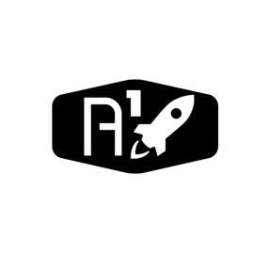

DESIGN DOCUMENT

Area : Converse Engine

Category: Feed (Avionics)

TEAM: Propulsion

Nyameaama Gambrah